

Riding out the tough challenges posed by the pandemic in the past three years, the Hong Kong aviation industry celebrated its recovery last year, gradually returning to normalcy in an orderly and safe manner.

In the face of this unprecedented global health crisis and its impacts on the aviation industry worldwide, the Civil Aviation Department remained steadfast and committed to rendering reliable, efficient and professional services. How can the department, as a regulatory authority, also be a facilitator, by implementing facilitating measures in various areas to assist industry stakeholders to cope with the challenges that may arise ahead on the path towards a full recovery of aviation sector?

Speaker Profile
LIU Chi-yung, Victor, JP
Director-General of Civil Aviation | HKSAR Government

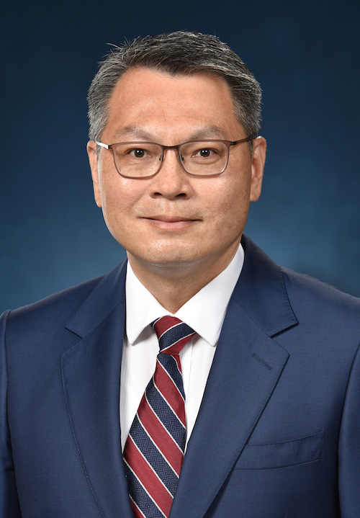 | Mr Victor Liu has over 30 years of aviation experiences. Before taking up the Director-General of Civil Aviation position, he has held different senior management positions in various technical divisions of the Hong Kong Civil Aviation Department. Victor was previously the Chairman of the International Civil Aviation Organization Asia Pacific Regional Aviation Safety Group, and the Vice President – Asia of International Federation of Airworthiness.  Victor graduated from the University of Hong Kong. He also holds a Specialized Master Degree in Aviation Safety (Aircraft Airworthiness) from Ecole Nationale de l’Aviation Civile, France.  He is a professional pilot with experiences in scheduled airlines, business charter as well as search and rescue operations. He is also a Fellow of the Hong Kong Institute of Engineers.

Date: | 28 May 2024, Tuesday
Time: | 12:30pm – 2:30pm (Registration starts at 12:15pm)
Venue: | Artyzen Club (at 401A, 4/F Shun Tak Centre, 200 Connaught Road, Central)
Fee: | HK$600/ person (for CILTHK members)/  HK$700/ person (for non-CILTHK members)
Quota: | 40 | Medium: | Cantonese | Deadline: | 21 May 2024

Both CILTHK members and friends are welcome to join.

CILTHK Executive Luncheon Series 2024
Session 02 - A regulator can also be a facilitator
NOTES:

1. Payment Method:

By Cheque please complete the below form and return it by mail or by fax or by email to:
The Chartered Institute of Logistics and Transport in Hong Kong (CILTHK)
7/F Yue Hing Building, 103 Hennessy Road, Wanchai, Hong Kong
F 2866-6118 E ao1@cilt.org.hk
Cheque(s) should be made payable to ‘CILTHK’ or ‘The Chartered Institute of Logistics and Transport in Hong Kong’ and send together with this registration form to the above address. OR;

By FPS to Bank of East Asia A/C No. 015-248-68-00410-0 “CILTHK” (Please send your transfer record including full name to CILTHK Office by email at ao1@cilt.org.hk for verification of payment use.) OR;

By Cash payment in person at CILTHK Office.

2. Your request will only be confirmed upon receipt of the payment.

3. For more information, please contact:
CILTHK Secretariat Office at 2877-0330 or email to ao1@cilt.org.hk

Registration
Please √ the appropriate box
Title:
  Prof Dr. Ir Mr. Ms. Miss Others:
CILTHK Membership No.:
Company.: |  |  |  |  |  |  |  |  | Position:
Contact Person:
Office Tel: |  |  |  |  |  |  |  |  | Mobile:
Email: |  |  |  |  |  |  |  |  | Fax:
Please reserve seat X @ HK$600 (for CILTHK members)  @ HK$700 (for non-members) |  |  |  |  |  |  |  |  |  | HK$
 |  |  |  |  |  |  |  |  |  | HK$
The following Guests will be attending the Luncheon on 28 May 2024.
Guest List
1 | Full Name:
Company: |  |  |  |  |  |  | Position:
2 | Full Name:
Company: |  |  |  |  |  |  | Position:
3 | Full Name:
Company: |  |  |  |  |  |  | Position:
Cheque No: |  |  |  |  |  | Total: |  |  |  | HK$

