

CILTHK Executive Luncheon Series was held from March onwards in 2023. Key government officials will be invited to share with members and guests the latest updates on a diverse range of important policies and developments in the transport and logistics industry and Hong Kong. We believe that it will be an unmatched opportunity to share and exchange ideas between our guest speakers and the local transport and logistics professionals.
Mr. LAM Sai-hung, GBS, JP, the Secretary for Transport and Logistics will share his personal experience after one and a half years serving as the Secretary of Transport and Logistics in this session.
Speaker Profile
LAM Sai-hung, GBS, JP
Secretary for Transport and Logistics | HKSAR Government

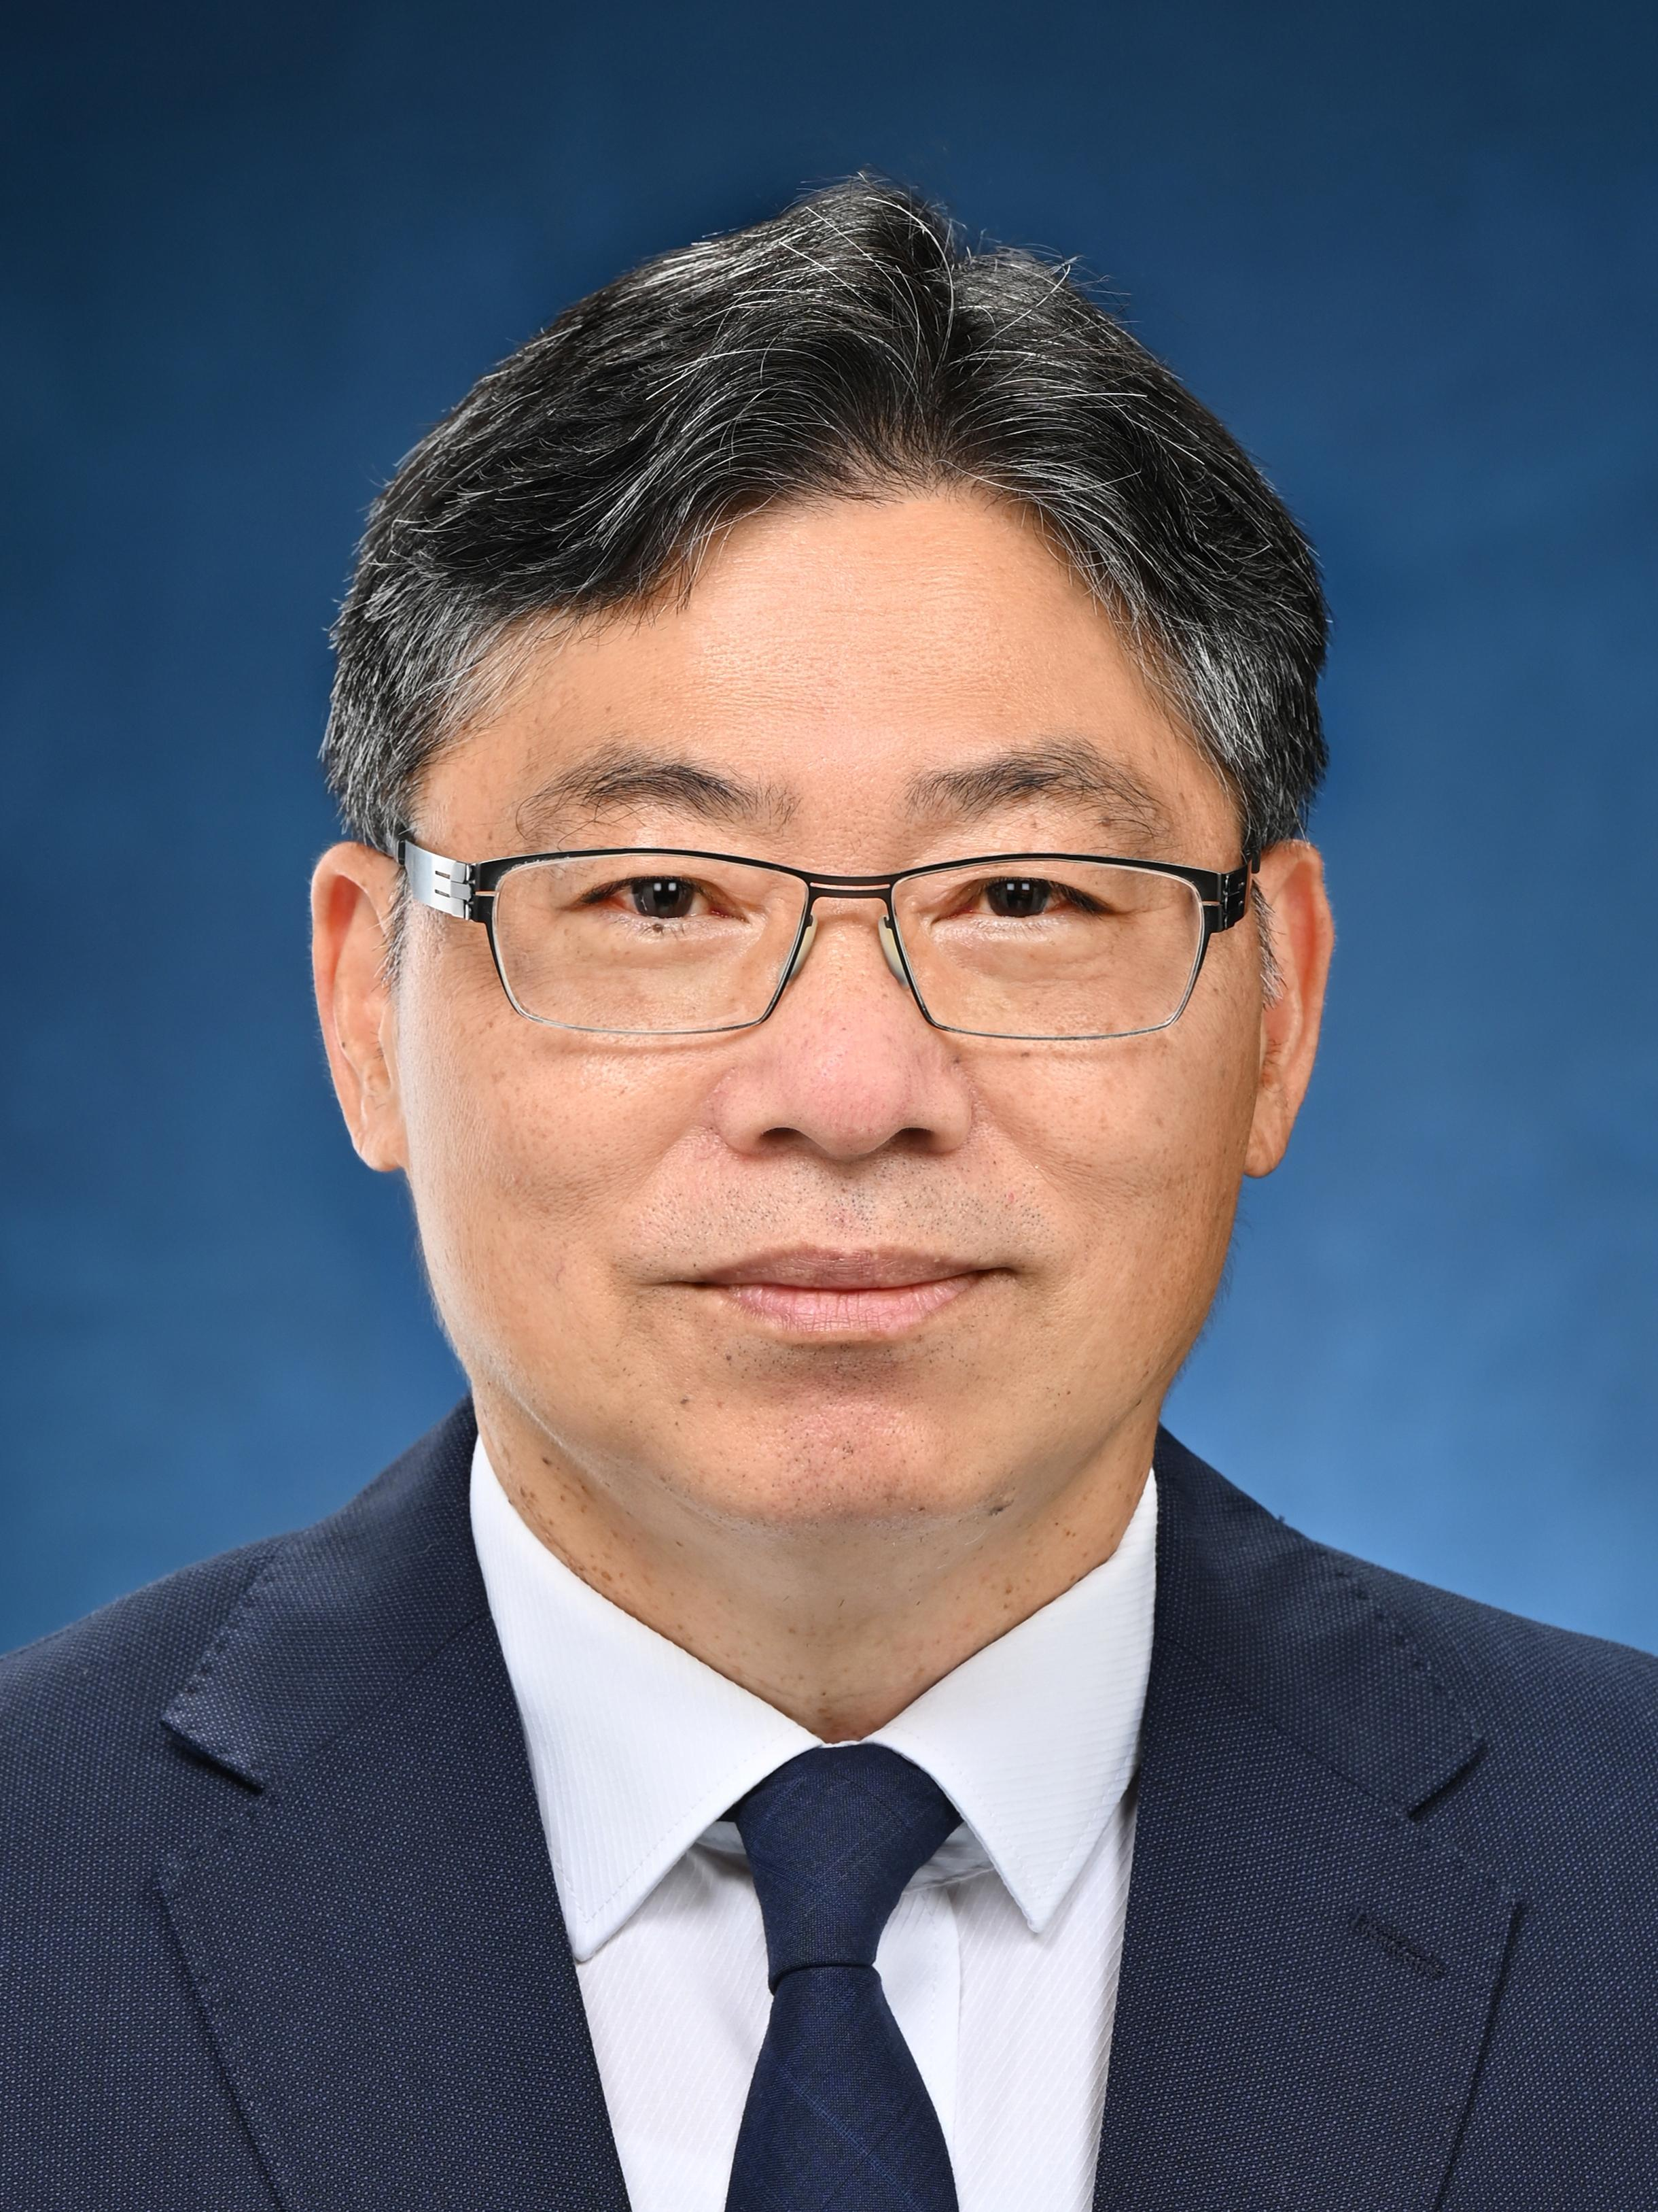 | Mr Lam Sai-hung was appointed the Secretary for Transport and Logistics on 1 July 2022.  Mr Lam joined the Government as a civil engineering graduate in 1983 and became an assistant engineer in 1986. During his service in the Government, Mr Lam worked in different works departments and bureau, participating in various public works projects including bridges, roads, railways, and site formation. He was appointed the Director of Civil Engineering and Development in August 2016, overseeing the planning and implementation of new development areas and major infrastructures. Between October 2018 and October 2021, he was the Permanent Secretary for Development (Works) overseeing public works policy and infrastructural development.

Date: | 5 Mar 2024, Tuesday
Time: | 12:30pm – 2:30pm (Registration starts at 12:15pm)
Venue: | Artyzen Club (at 401A, 4/F Shun Tak Centre, 200 Connaught Road, Central)
Fee: | HK$600/ person (for CILTHK members)/  HK$700/ person (for non-CILTHK members)
Quota: | 40 | Medium: | Cantonese | Deadline: | 28 Feb 2024

Both CILTHK members and friends are welcome to join.

CILTHK Executive Luncheon Series 2024
Session 01 - Life as a Principal Official
NOTES:

1. Payment Method:

By Cheque please complete the below form and return it by mail or by fax or by email to:
The Chartered Institute of Logistics and Transport in Hong Kong (CILTHK)
7/F Yue Hing Building, 103 Hennessy Road, Wanchai, Hong Kong
F 2866-6118 E info@cilt.org.hk
Cheque(s) should be made payable to ‘CILTHK’ or ‘The Chartered Institute of Logistics and Transport in Hong Kong’ and send together with this registration form to the above address. OR;

By FPS to Bank of East Asia A/C No. 015-248-68-00410-0 “CILTHK” (Please send your transfer record including full name to CILTHK Office by email at info@cilt.org.hk for verification of payment use.) OR;

By Cash payment in person at CILTHK Office.

2. Your request will only be confirmed upon receipt of the payment.

3. For more information, please contact:
CILTHK Secretariat Office at 2877-0330 or email to info@cilt.org.hk

Registration
Please √ the appropriate box
Title:
  Prof Dr. Ir Mr. Ms. Miss Others:
CILTHK Membership No.:
Company.: |  |  |  |  |  |  |  |  | Position:
Contact Person:
Office Tel: |  |  |  |  |  |  |  |  | Mobile:
Email: |  |  |  |  |  |  |  |  | Fax:
Please reserve seat X @ HK$600 (for CILTHK members)  @ HK$700 (for non-members) |  |  |  |  |  |  |  |  |  | HK$
 |  |  |  |  |  |  |  |  |  | HK$
The following Guests will be attending the Luncheon on 05 Mar 2024.
Guest List
1 | Full Name:
Company: |  |  |  |  |  |  | Position:
2 | Full Name:
Company: |  |  |  |  |  |  | Position:
3 | Full Name:
Company: |  |  |  |  |  |  | Position:
Cheque No: |  |  |  |  |  | Total: |  |  |  | HK$

