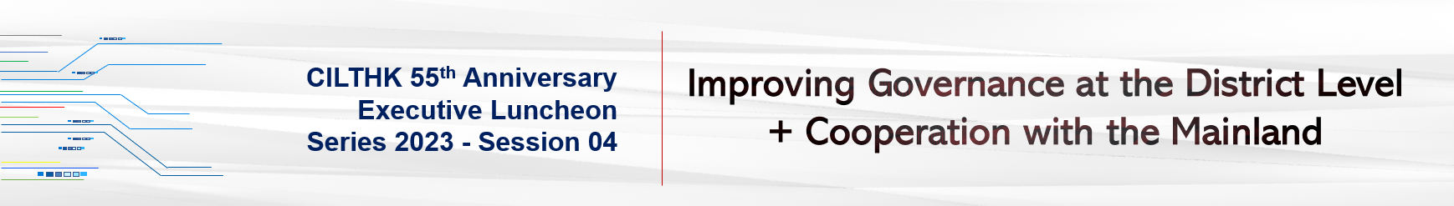

In recent years, there had been acts in district councils going against and beyond their statutory functions as district advisory bodies. The government has to reform the district councils, review and streamline the district governance structure so as to improve the efficacy of district governance and respond to public demands.
Making good use of her unique advantages, Hong Kong has played and will continue to play a significant role in the development of China.
Speaker Profile
WOO Kin Man, Clement, MH, JP
Under Secretary for Constitutional & Mainland Affairs | HKSAR Government

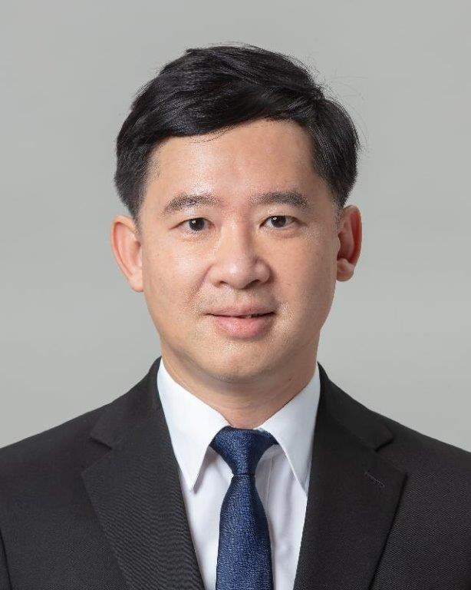 | Mr Clement Woo Kin-man, Under Secretary for Constitutional and Mainland Affairs, the Government of the Hong Kong Special Administrative Region, has joined the government since October 2021. Mr Woo was a member of the Tai Po District Council from 2016 to 2019 and has been dedicated to community and youth services over the years. He has made notable contributions to society through his participation in various government statutory and advisory bodies including the Committee on the Promotion of Civic Education, the Family Council and the Basic Law Promotion Steering Committee, as well as his service as an auxiliary police officer.  Mr Woo has ample experience in running manufacturing, trade and investment companies locally, in the Mainland and abroad. He holds a Bachelor’s degree in Mechanical Engineering from Imperial College London and an Executive Master’s degree in Public Administration from Tsinghua University.

Date: | 24 Oct 2023, Tuesday
Time: | 12:30pm – 2:30pm (Registration starts at 12:15pm)
Venue: | Artyzen Club (at 401A, 4/F Shun Tak Centre, 200 Connaught Road, Central)
Fee: | HK$600/ person (for CILTHK members)/  HK$700/ person (for non-CILTHK members)
Quota: | 40 | Medium: | Cantonese | Deadline: | 18 Oct 2023

Both CILTHK members and friends are welcome to join.

CILTHK 55th Anniversary | Executive Luncheon Series 2023
Session 04 | Improving Governance at the District Level + Cooperation with the Mainland |

NOTES:

1. Payment Method:
By Credit Card please complete the online form and the link is as below.
https://www.cilt.org.hk/en-us/Event/Detail.aspx?id=250 OR;

By Cheque please complete the below form and return it by mail or by fax or by email to:
The Chartered Institute of Logistics and Transport in Hong Kong (CILTHK)
7/F Yue Hing Building, 103 Hennessy Road, Wanchai, Hong Kong
F 2866-6118 E ao1@cilt.org.hk
Cheque(s) should be made payable to ‘CILTHK’ or ‘The Chartered Institute of Logistics and Transport in Hong Kong’ and send together with this registration form to the above address.

2. Your request will only be confirmed upon receipt of the payment.

3. For more information, please contact:
Ms Molly LAM at 2877-0330 or email to ao1@cilt.org.hk

Registration
Please √ the appropriate box
Title:
  Prof Dr. Ir Mr. Ms. Miss Others:
CILTHK Membership No.:
Company.: |  |  |  |  |  |  |  |  | Position:
Contact Person:
Office Tel: |  |  |  |  |  |  |  |  | Mobile:
Email: |  |  |  |  |  |  |  |  | Fax:
Please reserve seat X @ HK$600 (for CILTHK members)  @ HK$700 (for non-members) |  |  |  |  |  |  |  |  |  | HK$
 |  |  |  |  |  |  |  |  |  | HK$
The following Guests will be attending the Luncheon on 18 Oct 2023.
Guest List
1 | Full Name:
Company: |  |  |  |  |  |  | Position:
2 | Full Name:
Company: |  |  |  |  |  |  | Position:
3 | Full Name:
Company: |  |  |  |  |  |  | Position:
Cheque No: |  |  |  |  |  | Total: |  |  |  | HK$

