CILTHK 55th Anniversary | Executive Luncheon Series 2023 |

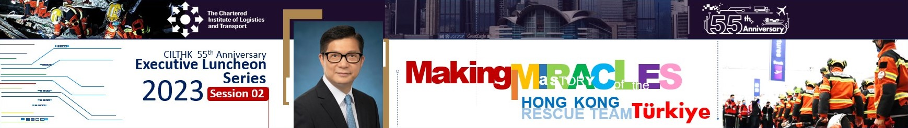

The Chartered Institute of Logistics and Transport in Hong Kong (CILTHK), founded in 1968, is celebrating its 55th Anniversary this year. To commemorate this momentous occasion, we have organised a 55th Anniversary Luncheon Series which serves to provide a platform for nurturing close and long-standing relationships between the government and the transport and logistics industry. It aims to drive the industry to stay competitive in Hong Kong and the Greater Bay Area, and, by extension, in the rest of the world.

This Luncheon Series will consist of 3-4 luncheons from March onwards in 2023. Key government officials will be invited to share with members and guests the latest updates on a diverse range of important policies and developments in the transport and logistics industry and Hong Kong. We believe that it will be an unmatched opportunity to share and exchange ideas between our guest speakers and the local transport and logistics professionals.
_______________________________________________________________________________________________________________________________________________________________________________________
Session 02 | Making Miracles –
A Story of the HK Rescue Team in Türkiye |

In this session, the Secretary for Security, Mr TANG Ping-keung, will share the rescue mission and stories of HKSAR search and rescue team in the recent Türkiye earthquake. Through this special mission, we can see how the team raced against time to save lives despite facing with difficult conditions. With love, perseverance and the support from our country, the team completed the first overseas rescue mission of HKSAR by rescuing survivors successfully

Both CILTHK members and friends are welcome to join.

CILTHK 55th Anniversary | Executive Luncheon Series 2023
Session 02 | Making Miracles – A Story of the HK Rescue Team in Türkiye |

Date: |  | 22 May 2023, Monday
Time: |  | 12:30pm – 2:30pm (Registration starts at 12:15pm)
Venue: |  | Artyzen Club (at 401A, 4/F Shun Tak Centre, 200 Connaught Road, Central)
Fee: |  | HK$600/ person (for CILTHK members)/  HK$700/ person (for non-CILTHK members)
Quota: |  | 40
Medium: |  | Cantonese
Deadline: |  | 15 May 2023
 | Speaker Profile
TANG Ping-keung, GBS PDSM, JP
Secretary for Security | HKSAR Government

 | 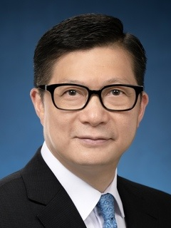 |  | Mr Tang joined the Hong Kong Police Force as an Inspector in 1987 and was appointed as Commissioner of Police in 2019. He has been Secretary for Security since June 2021. Mr Tang holds a Bachelor's degree in Social Science, a Master's degree in Business Administration and a Master's degree in International Security and Strategy.
CILTHK 55th Anniversary | Executive Luncheon Series 2023
Session 02 | Making Miracles – A Story of the HK Rescue Team in Türkiye |

NOTES:

1. Payment Method:
By Credit Card please complete the online form and the link is as below.
https://www.cilt.org.hk/en-US/Event/Detail.aspx?id=233 OR;

By Cheque please complete the below form and return it by mail or by fax or by email to:
The Chartered Institute of Logistics and Transport in Hong Kong (CILTHK)
7/F Yue Hing Building, 103 Hennessy Road, Wanchai, Hong Kong
F 2866-6118 E ao1@cilt.org.hk
Cheque(s) should be made payable to ‘CILTHK’ or ‘The Chartered Institute of Logistics and Transport in Hong Kong’ and send together with this registration form to the above address.

2. Your request will only be confirmed upon receipt of the payment.

3. For more information, please contact:
Ms Molly LAM at 2877-0330 or email to ao1@cilt.org.hk

Registration
Please √ the appropriate box
Title:
  Prof Dr. Ir Mr. Ms. Miss Others:
CILTHK Membership No.:
Company.: |  |  |  |  |  |  |  |  | Position:
Contact Person:
Office Tel: |  |  |  |  |  |  |  |  | Mobile:
Email: |  |  |  |  |  |  |  |  | Fax:
Please reserve seat X @ HK$600 (for CILTHK members)  @ HK$700 (for non-members) |  |  |  |  |  |  |  |  |  | HK$
 |  |  |  |  |  |  |  |  |  | HK$
The following Guests will be attending the Luncheon on 22 May 2023.
Guest List
1 | Full Name:
Company: |  |  |  |  |  |  | Position:
2 | Full Name:
Company: |  |  |  |  |  |  | Position:
3 | Full Name:
Company: |  |  |  |  |  |  | Position:
Cheque No: |  |  |  |  |  | Total: |  |  |  | HK$

